Details of person completing this record
Name
Position/Role
Service Name
Date record was made |  | Time
Signature
Child Details
Child’s Full Name
Date of Birth |  | Age
Incident/Injury/Trauma/Illness Details
Date of Incident |  | Time of Incident | □am □pm
Location where incident occurred
Name of person who witnessed the incident/
injury/trauma/illness
Signature of Witness
Date
Incident Details
Circumstances leading to the incident/
injury/trauma/illness, including any apparent symptoms
Circumstances if child appeared to be missing or otherwise unaccounted for (incl. duration, who found child, etc.)
Circumstances if child appeared to have been taken or removed from service or was locked in/out of service (incl. who took the child, duration)

Nature of injury/trauma/illness:  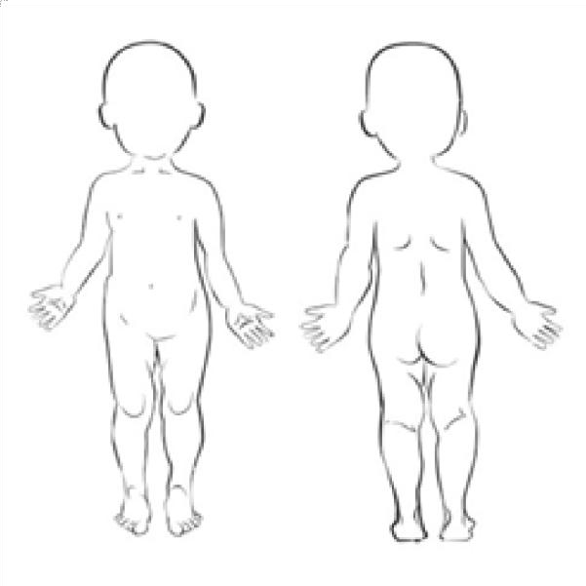 | - Abrasion / scrape  - Allergic reaction  - (not anaphylaxis)  - Amputation  - Anaphylaxis  - Asthma / respiratory  - Bite wound  - Bruise  - Broken bone /  fracture/dislocation  - Burn / sunburn  - Choking  - Concussion  - Crush / jam  - Cut / open wound  - Drowning (non-fatal)  - Electric shock  - Eye injury | - Infectious disease (incl. gastrointestinal)  - High temperature  - Ingestion / inhalation / insertion  - Internal injury / infection  - Poisoning  - Rash  - Respiratory  - Seizure/unconscious/ convulsion  - Sprain / swelling  - Stabbing / piercing  - Tooth  - Venomous bite / sting  - Other (please specify)  .........................................  .........................................

Action Taken
Details of action taken
(including first aid, administration of medication, etc.)
Did emergency services  attend? | □Yes □No | Time emergency  services contacted | □am □pm
Was medical attention sought from a registered  practitioner / hospital? |  | □Yes □No
If yes to either of the above, provide details
Have any steps been taken to prevent or minimise this type of incident in the future?

□Yes □No If yes, provide details.

Notifications (including attempted notifications)
Parent/Guardian |  | Name
Date |  |  | Time/s:
Coordinator |  | Name
Date |  |  | Time
Parent Acknowledgment
I, | (insert name next)
Have been notified of my child’s □incident □injury □trauma □illness (please select)
Date |  |  | Signature
Additional Notes

